KIWAALA KIDS SSUUBI PROJECT
kiwaalaproject@yahoo.com - www.kiwaalakids.weebly.com

REPORT FOR PROJECT NO. 2
Background information
The village of Kiwaala in Uganda, Eastern Africa, lies a 20 minutes drive from Masaka town.
The village is home to about 600 families who have been bothered together with threats of hunger, thirst, illiterate and now HIV Aids.
Kiwaala had been dubbed “mission impossible” by the Masaka Diocese, but together we want to change this and make it mission possible!

The Kiwaala Kids Ssuubi Project is to help the poor, underprivileged children, and also to help their parents who cannot always afford a good education for their children.

Our mission: Empowering Kiwaala to become a model self-supporting and self-sufficient community as in farming practices, small business, increased literacy rates, and better health outcomes for children and mothers.

Project description

Name: Shelter the homeless

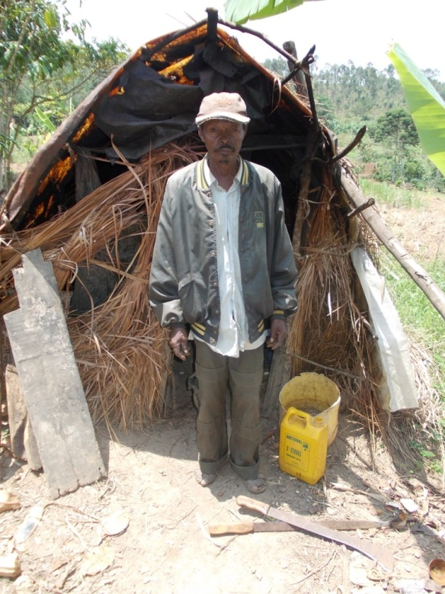
71 year old Misago Joseph who looks after 2 orphaned grandchildren lives in extreme poverty juggling lots of threats including hunger, Diseases and homeless.
His house was destroyed by heavy rains. The project was to construct a house for Joseph and the children from the bricks which were donated by the Chairman and the community of Kiwaala.
On October 13, 2012 Moses and Life Teen youth ministry constructed a house for Joseph and the children with support from Bill Mulcahy.

Project cost: 403000UGX =AUS $ 158
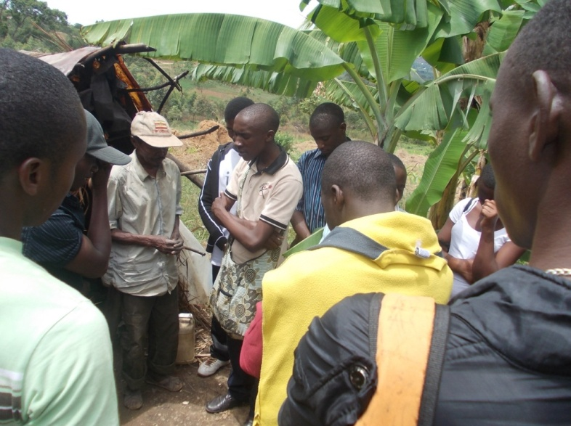
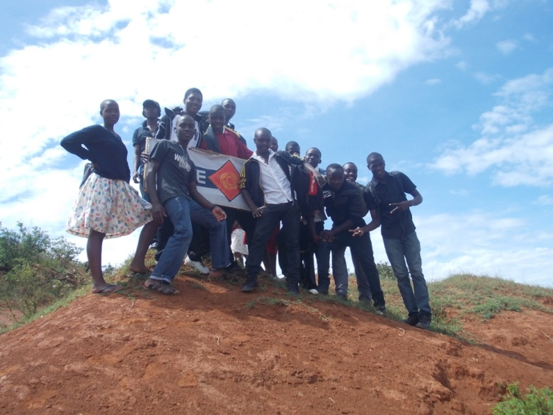
Item | Qty | Unit cost | Amount
Bricks | 3805 |  | Donated
Labor |  |  | Life Teen
Iron Sheets | 13 | 20,000 | 260,000/-
Doors | 1 | 50,000/- | 50,000/-
Windows | 2 | 30,000/- | 60,000/-
Nails | 1 Kg | 5000/- | 5,000/-
Ventilators | 8 | 1000/- | 8000/-
Poles | 5 | 4000/- | 20,000/-
TOTAL |  |  | 403,000/- $ 158
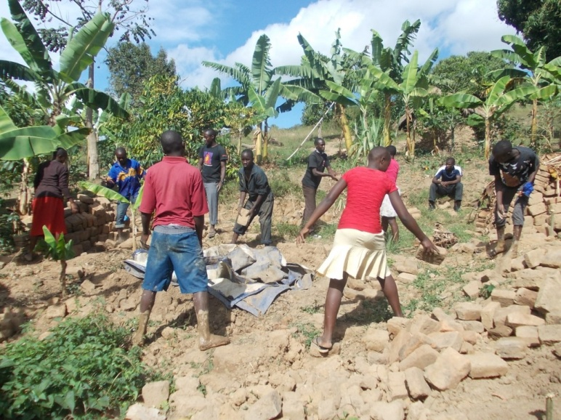
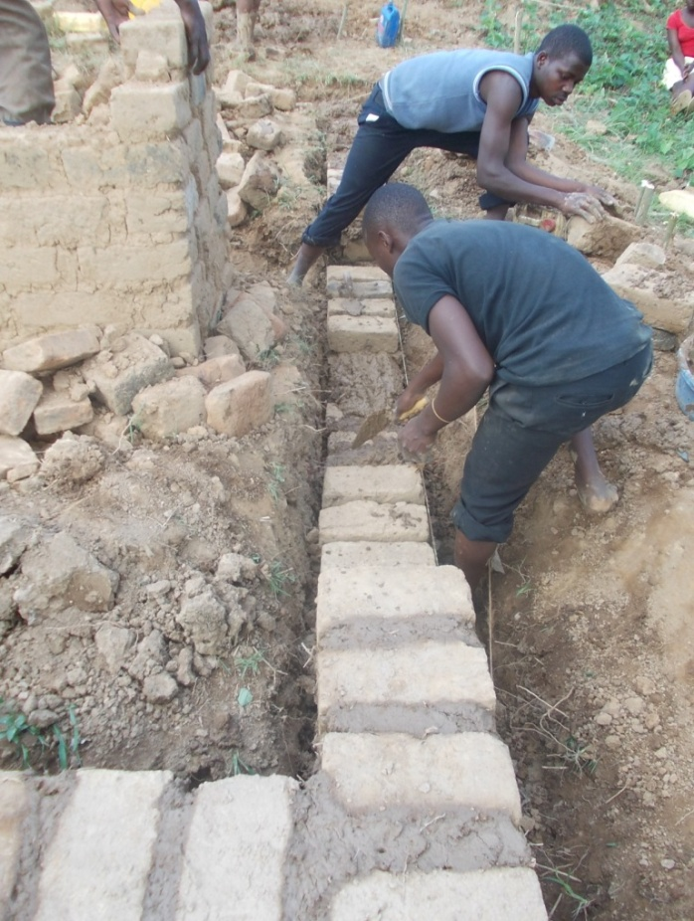
Youths from the ministry building the house »
Life Teen Youth Ministry arriving in Kiwaala
Life Teen Youth Ministry arriving in Kiwaala
Moses leading prayer before the work started

Message from Kasozi Moses
Project coordinator
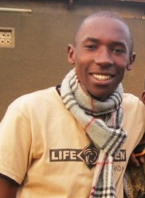
We want to thank all of you that have helped support this project with your generous pledges. We could not have done it without you
Its means a lot to us that you all believe in what we do and this motivate me to continue serving these disadvantaged people who are the victims of poverty and disease. I am inspired to serve with enthusiasm. So thank you from the bottom of my heart!
Our second project started and the chairman, community members and the youth from Life Teen were present and witnessed the transformation. Misago Joseph and his children were filled with tears of joy, their faces beamed with hope, joy and happiness.
Together we’re making a real and lasting difference in the lives of kids who would otherwise end up on streets begging, or shining shoes. Because of gifts like yours, these kids have hope for the future and this family will sleep well each night.
Thanks again, we hope you can join us in the next project!
Cheers
Kasozi Moses

Message from Bill Mulcahy
Project Director
In 2009, I made a personal commitment to “Stand with the Poor”. And for me, that also involved the country of Uganda. Don’t really know why, except that Uganda entered my life and has become a part of my everyday life. I visited Uganda later in 2009 and witnessed a poverty that I had never seen before. This humbled me and I decided that if people were to be assisted ‘ it began with me’. Through a chance encounter online, I met Moses and we began working together to assist the people of Uganda. To do this effectively we agreed that we should begin with 1 village and assist it to become a model community in rural Uganda.

And so Kiwaala Kids Ssubi Project began. Moses is the eyes, the ears, the hands and the feet in Uganda and he leads a wonderful youth ministry. Moses prioritises the needs of the community, such as this house project for Joseph and his grandchildren, and we enable it to happen.
So glad to be a part of these efforts
Bill Mulcahy

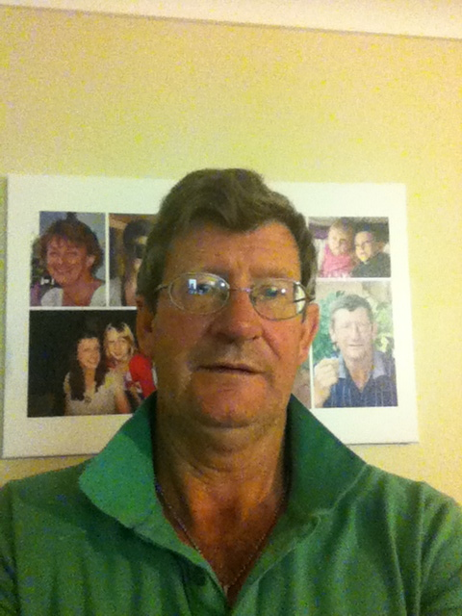

Message from a teen
Mugenyi Moses

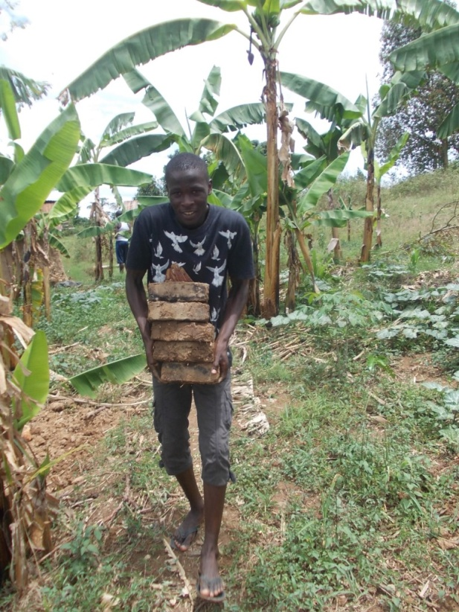
I am blessed to make a difference by serving our communities with Life Teen.
Getting involved is one of the best decisions I have ever made, I can use my talents, energy and skills to help others in need. This is what our faith calls us to do, Faith and Deeds, James 2:26 “For as the body apart from the spirit is dead, so also faith apart from works is dead.” My faith was alive while at Kiwaala, this is what I can do to blossoms my greatness.
I am very blessed to spend my time with the group and what we do as a group is incredibly great. We believe we can restore hope for the children and their families in Kiwaala.
May God Bless the work we do!

Message from Misago Joseph
Translated from Luganda

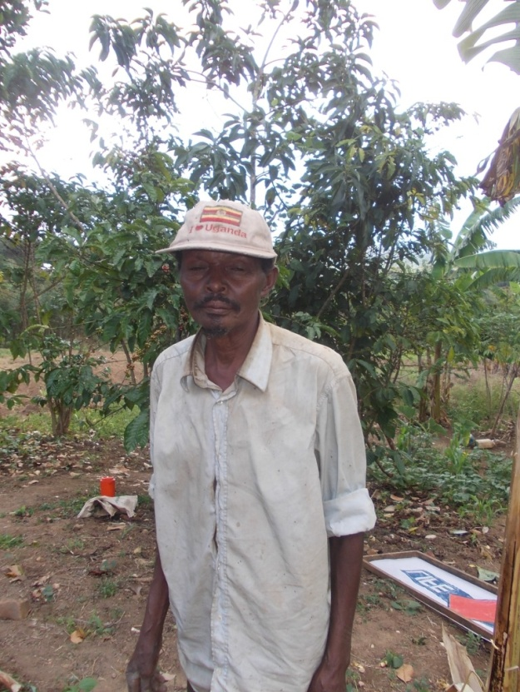
My heart is filled with joy; I thank the Almighty God who has enabled you to come here in our village and decide to help me and my family. My heart is filled with hope!!!!!
I have been in this shelter for 1 and half year and I have juggled coldness, sorrow and many threats.
I have been promising my grandchildren that tomorrow will be a great day, but tomorrow never arrived, I kept on promising them because I wanted them to be happy. Raising children in the face of homelessness is an enormous task. I thank you for standing in solidarity with me. God has answered my prayers, we shall sleep well each night, and my grandchildren will fear no more!
I am sure God who has started this work, will get it done!!!
God Bless you, Thank you.
Written by:
Kasozi Moses

